APPENDIX C

Gantt Chart.

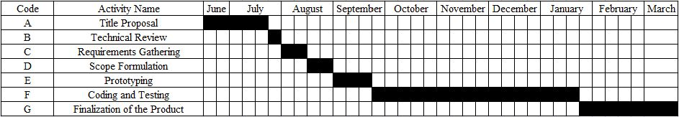

122